CURRICULUM VITAE

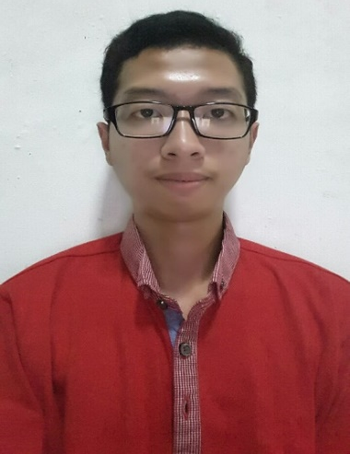
PERSONAL INFORMATION
First Name : Steven
Last Name : Kurniawan
Full Name : Steven Kurniawan
Email : stevenkurkur@gmail.com
Fax : -
Gender : Male
Date of Birth : October, 26th 1996
Marital Status : Single
Religion : Catholic
Address : Villa Kalijudan Indah N-19, Surabaya
City : Surabaya
State : East Java
Country : Indonesia
Postal/ZIP code : 60114
Mobile No : +628123527719
Nationality : Indonesian

- EDUCATION
FORMAL
- 2014 – Present
Institut Teknologi Sepuluh Nopember, Surabaya
Department of Informatics (Faculty of Information Technology)
- 2011 – 2014
Frateran Senior High School, Surabaya
Science
- 2008 – 2011
Angelus Custos 1 Junior High School, Surabaya
General
- 2002 – 2008
Angela Elementary School, Surabaya
General
- 2000 – 2002
Taman Rini Kindergarten School, Surabaya
General
NON FORMAL
2014 English Training at EF Surabaya
2014 Pelatihan Kepribadian ITS
2014 LKMM (Latihan Kemimpinan dan Manajemen Mahasiswa) Pra-Tingkat Dasar FTIf ITS
2015 LKMM (Latihan Kemimpinan dan Manajemen Mahasiswa) Tingkat Dasar HMTC ITS
2016 Microsoft Technology Associate Certification – Software Development Fundamentals
- PERSONAL SKILLS AND COMPETENCES
Languages:
- Mother Tongue : BAHASA INDONESIA
- Other Languages : ENGLISH
Computer skills and competences:
- Capable of operating Microsoft Office (Ms.Word, Ms.Excel, Ms.PowerPoint)
- Capable of programming with C, C++, Python languages
- Capable of programming with HTML, CSS, PHP, Javascript languages
- Capable of using SQL languages
Social skills and competences:
- Capable to work in pressure
- Strong sense of leadership

- ORGANIZATIONAL SKILLS AND COMPETENCES
ORGANIZATIONAL SKILLS
2012 – 2015 Head of Putra Altar Paroki Kelahiran Santa Perawan Maria,Surabaya
2014 – 2015 Apprentice of Research & Technology Department - Himpunan Mahasiswa Teknik Computer-Informatika
2015 Staff of Dana dan Usaha Schematics ITS 2015
2015 – 2016 Staff of Entrepreneurship Department - Himpunan Mahasiswa Teknik Computer-Informatika
2015 Vice President of LKMW (Latihan Keterampilan Manajemen Wirausaha) Tingkat Dasar HMTC ITS
2015 – 2016 Staff of Unit Event Department - KMK ITS
2015 Head of Publication and Documentation Division Kemah Rohani KMK ITS
2016 Staff of Technopreneurship Seminar ITS
2016 Staff of Dana dan Usaha Schematics ITS 2016
2016 – 2017 Staff of Entrepreneurship Department - Himpunan Mahasiswa Teknik Computer-Informatika

